**GIT Branching**

**Objective:** Commit HTML, CSS & JavaScript assignments into GIT.

SECTION-3 - (JavaScript assignments) Steps to follow:

1. Create a new branch ‘js-assignment’.

**Command used to create a Branch:**

git branch js-assignment

**Output:**

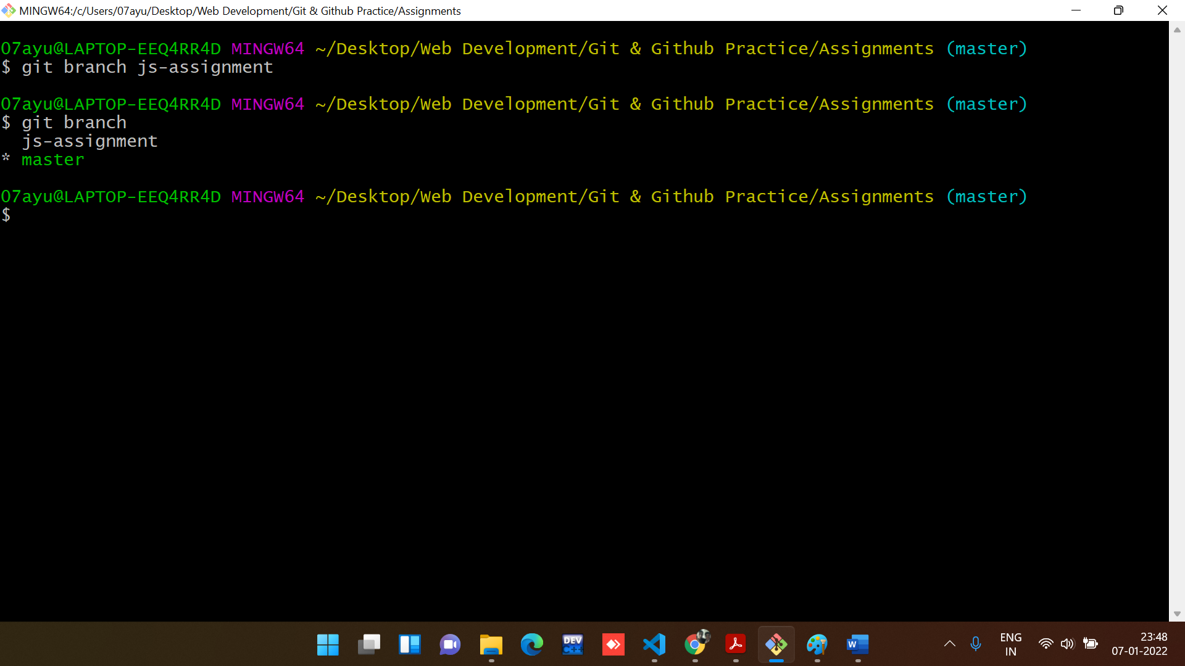

Note: git branch is a command to see all the branches.

1. Switch to ‘js-assignments’ branch.

**Command used to switch Branch:**

git checkout js-assignment

**Output:**

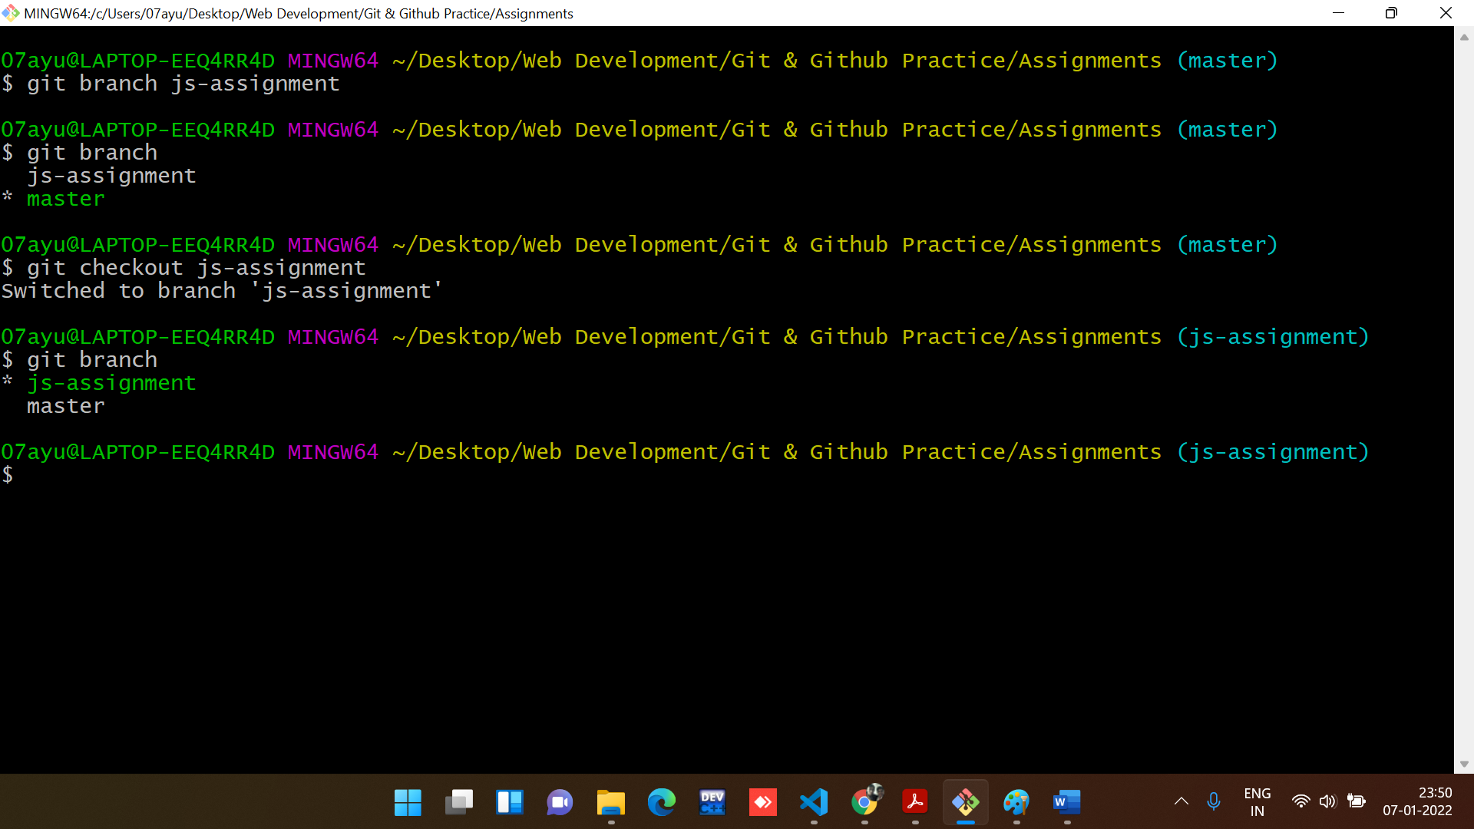

1. Copy all JavaScript assignments inside ‘Assignments’ folder.

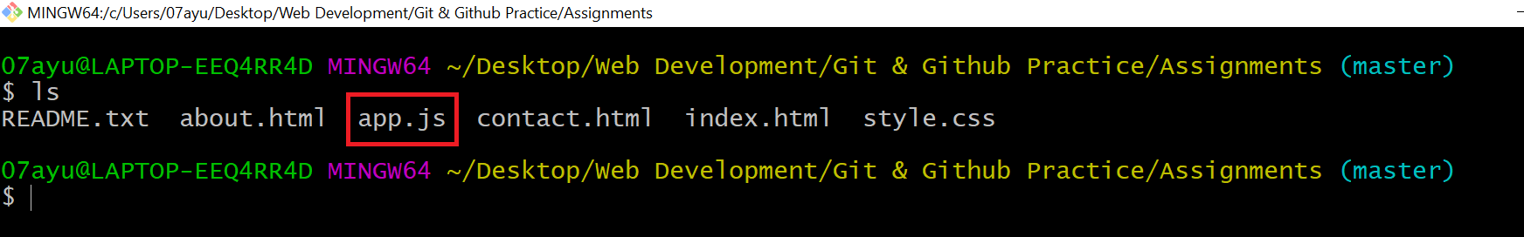

1. Commit JavaScript assignments into ‘js-assignments’ branch.

**Command to commit all the changes:**

git add -A

git commit -m “description”

**Output:**

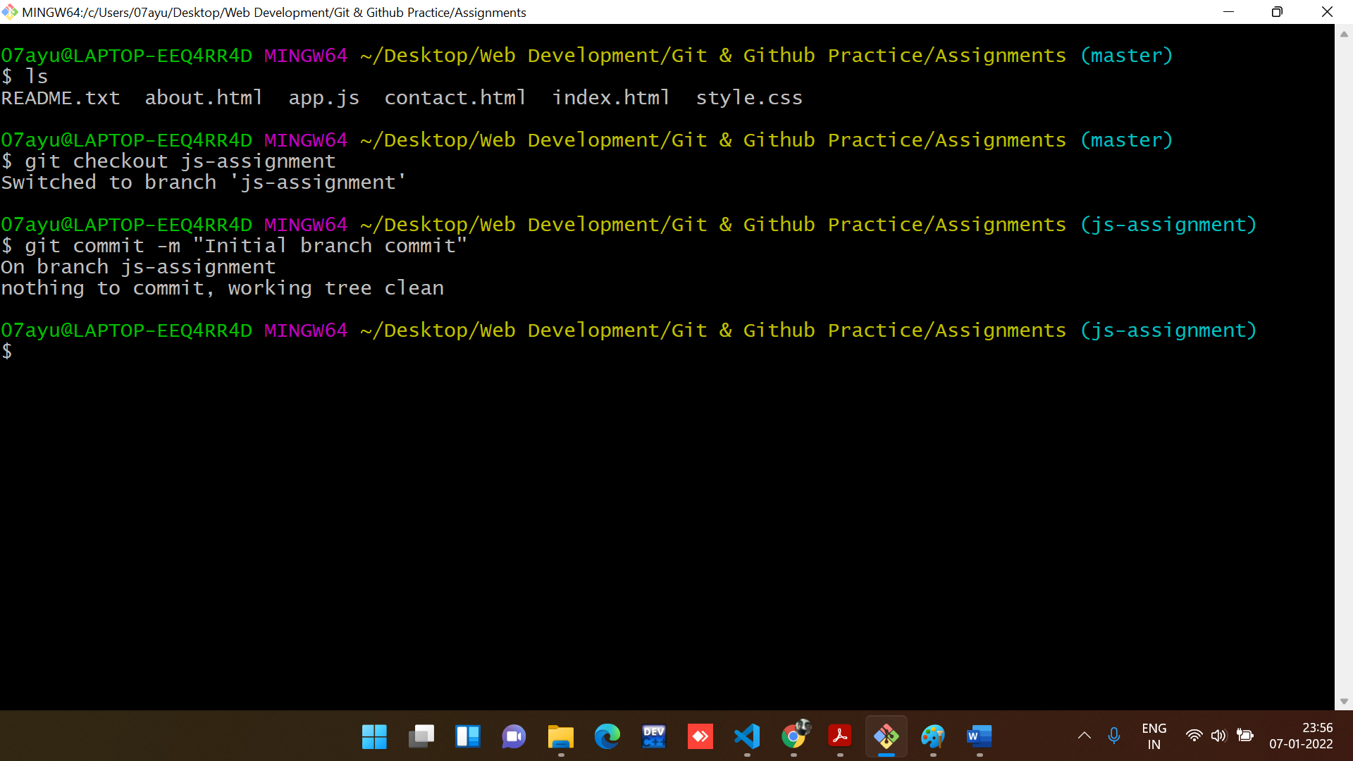

1. Make minor changes into README.txt file on line 1 belonging to ‘js-assignments’ branch.

**Changes made in README.txt in js-assignment branch.**

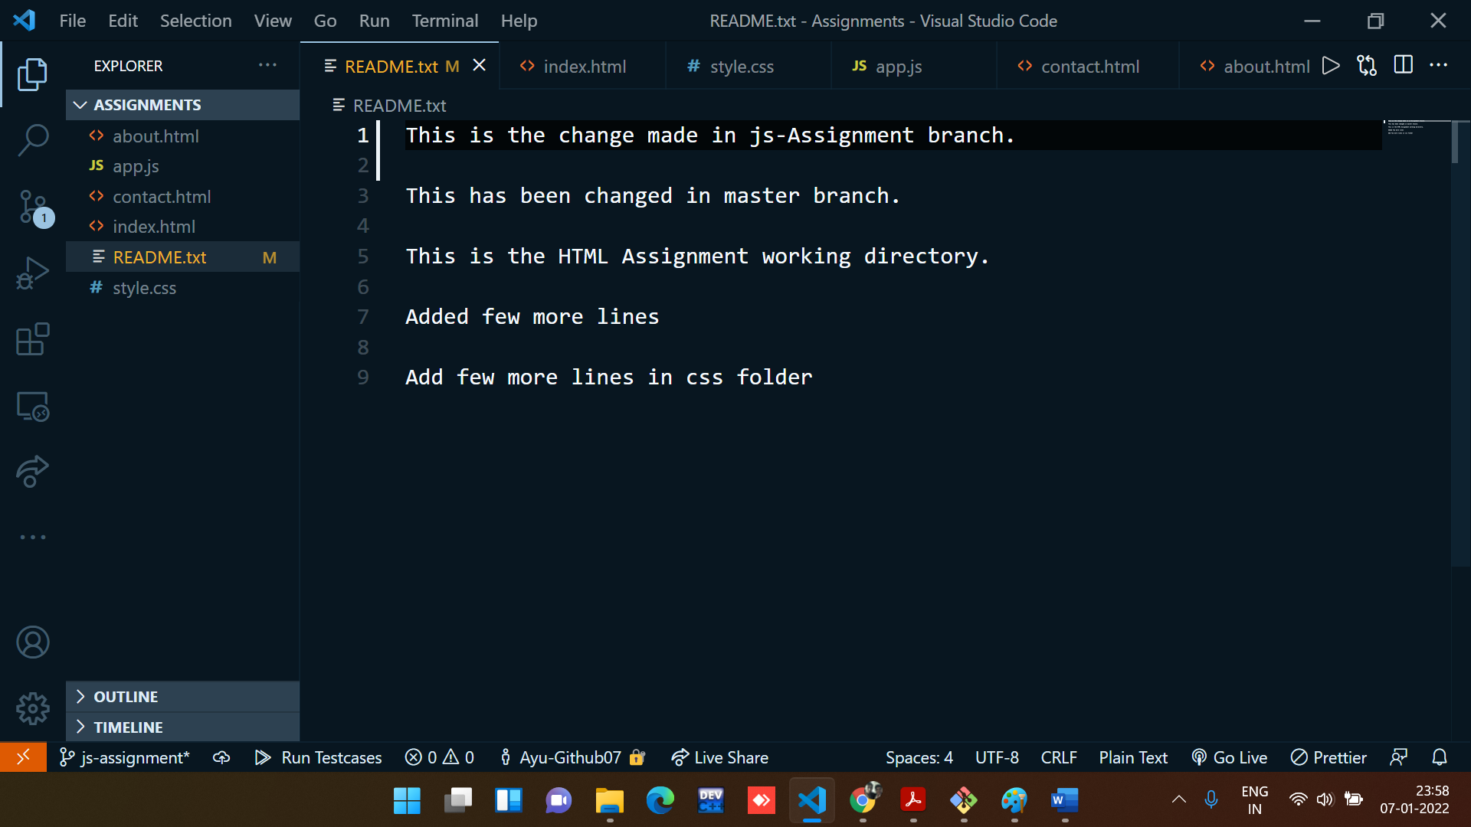

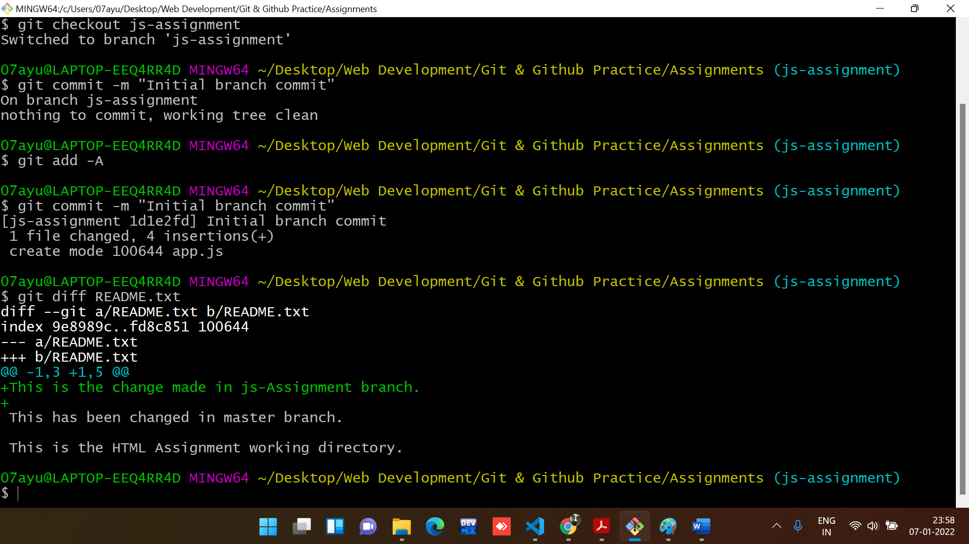

1. **Commit those changed files.**

**Command to commit all the changes:**

git add -A

git commit -m “description”

**Output:**

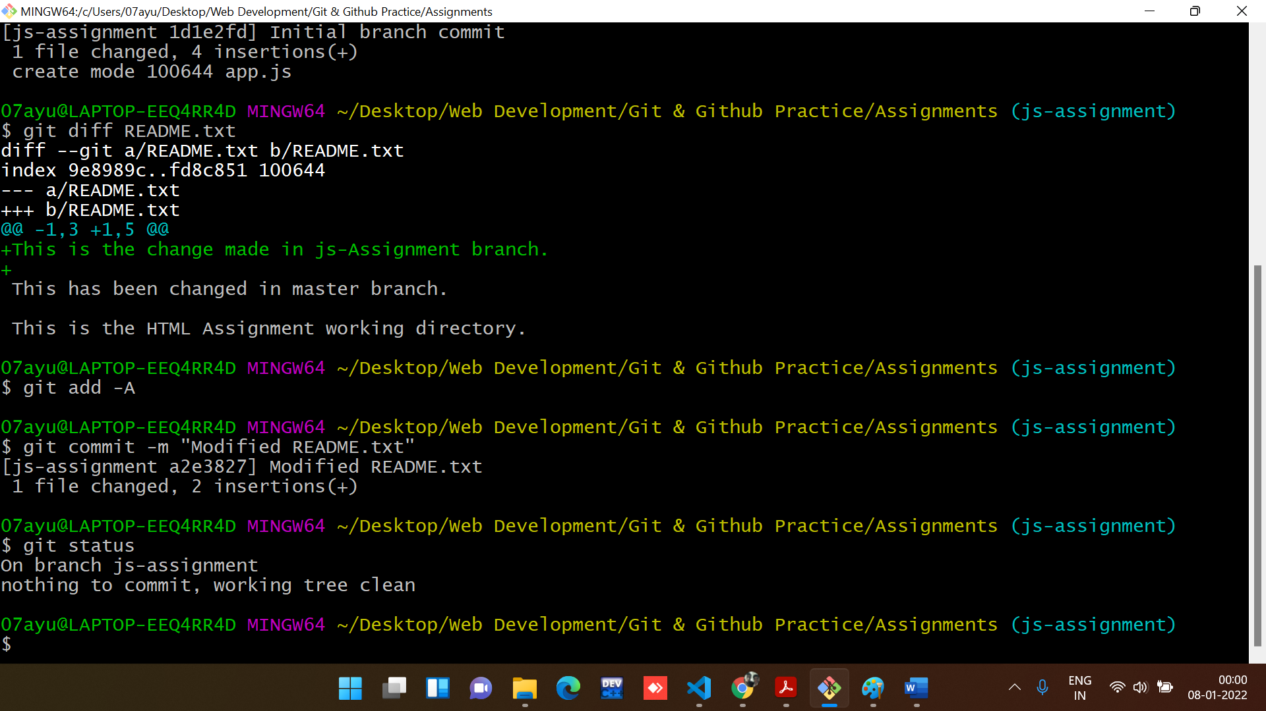

1. **Switch to master branch.**

**Command used to switch Branch:**

git checkout master

**Output:**

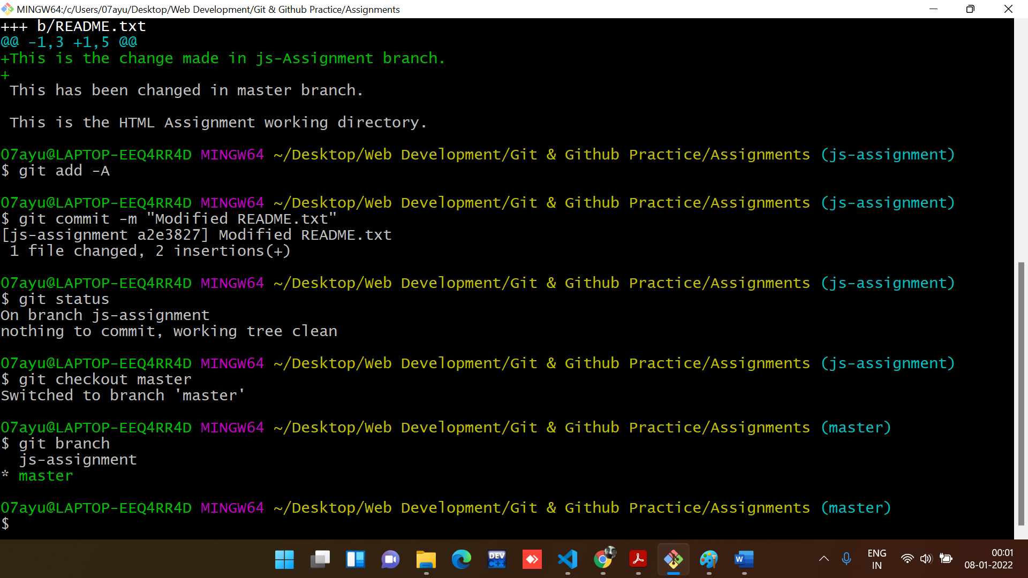

1. Make minor changes into README.txt file on line 1 & commit those changes into master.

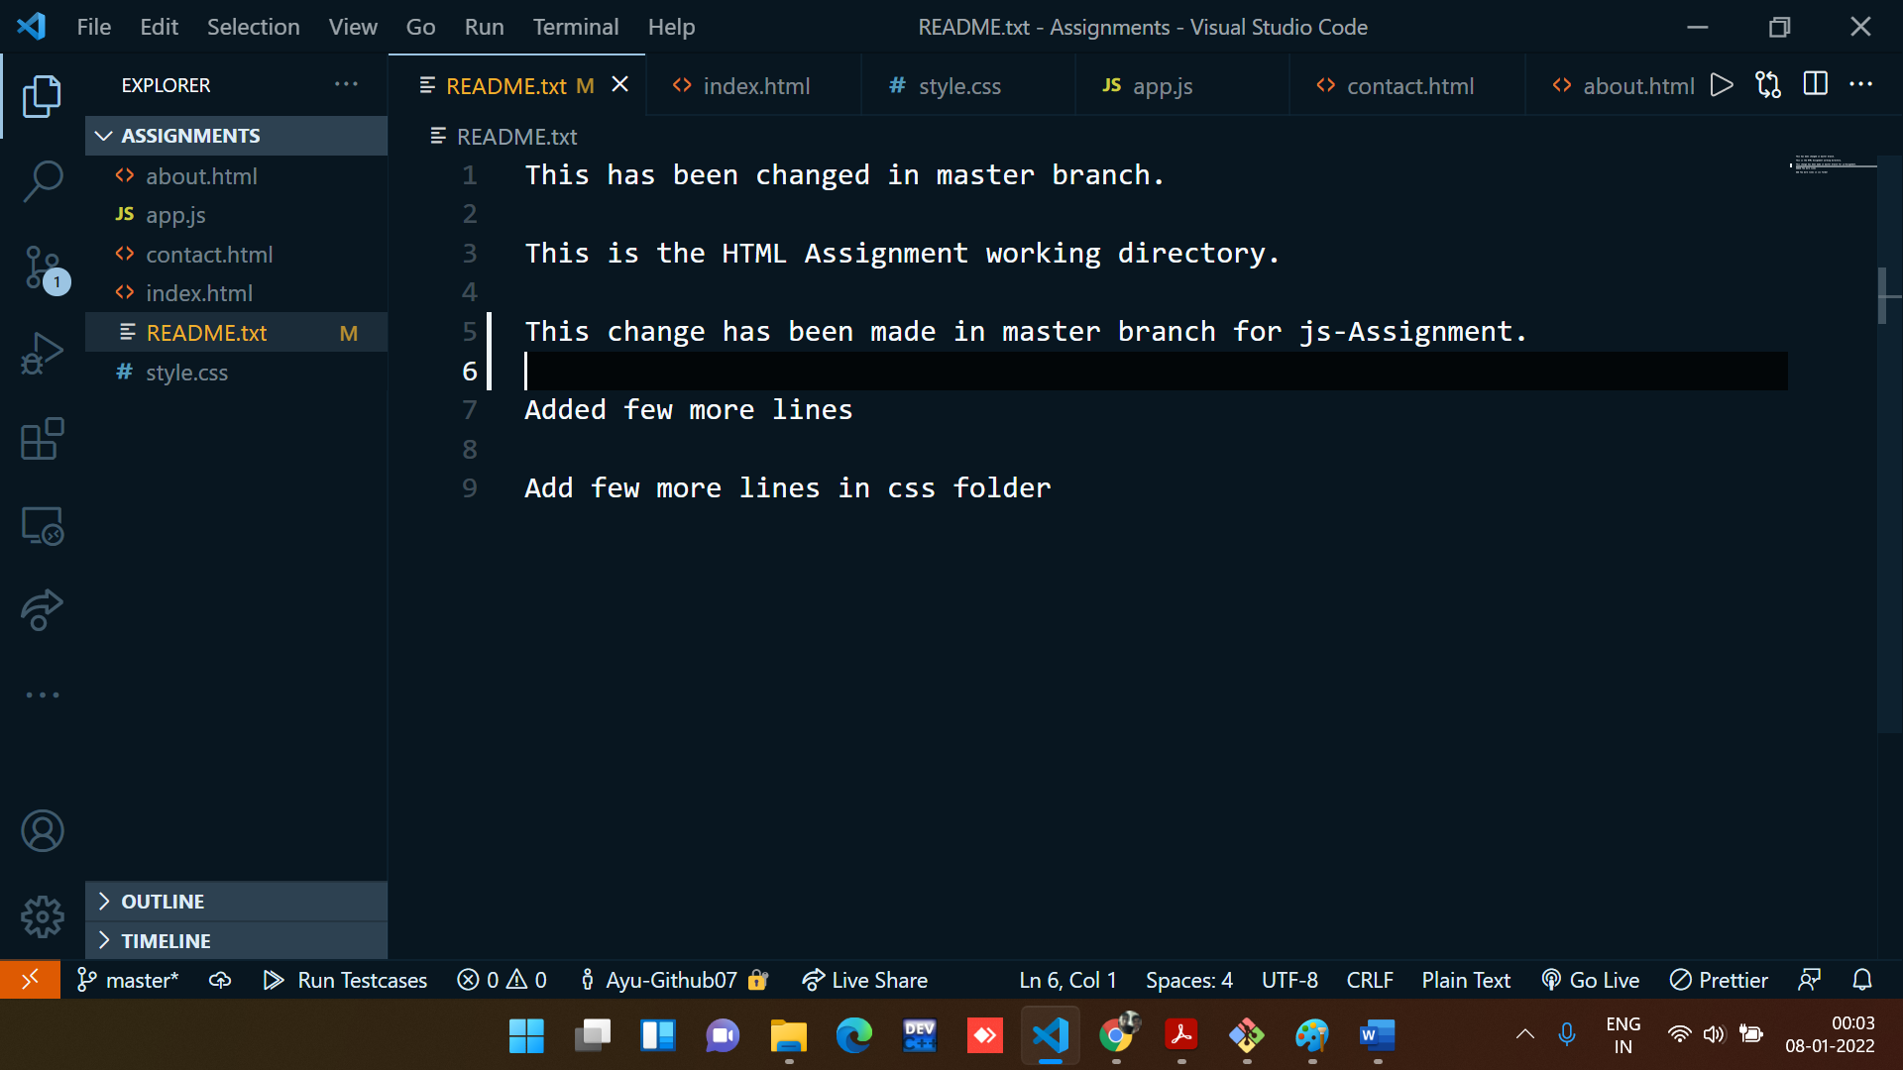

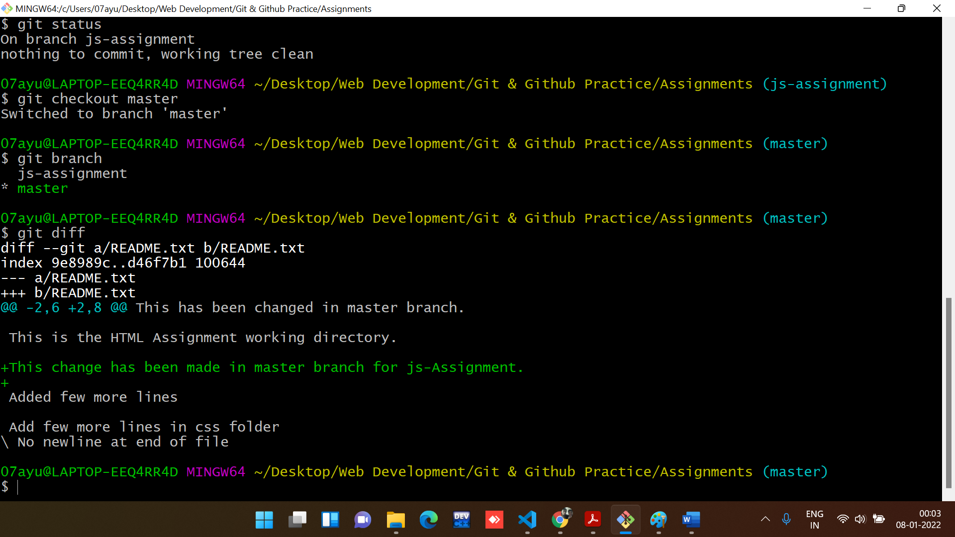

**Changes are committed:**

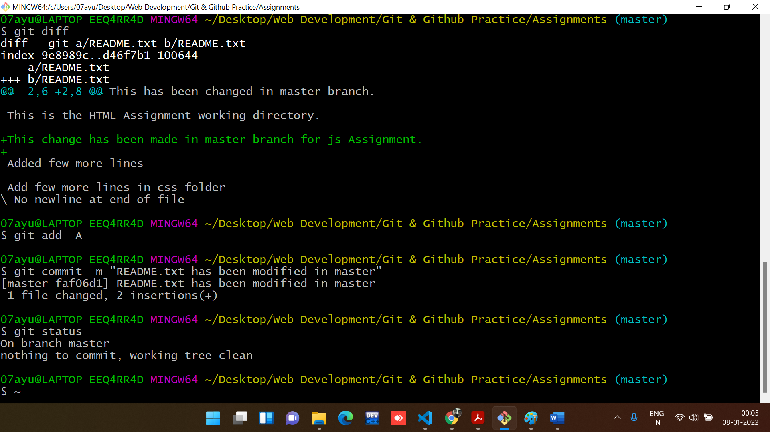

1. Again switch to ‘js-assignments’ branch.

**Command used to switch Branch:**

git checkout js-assignment

**Output:**

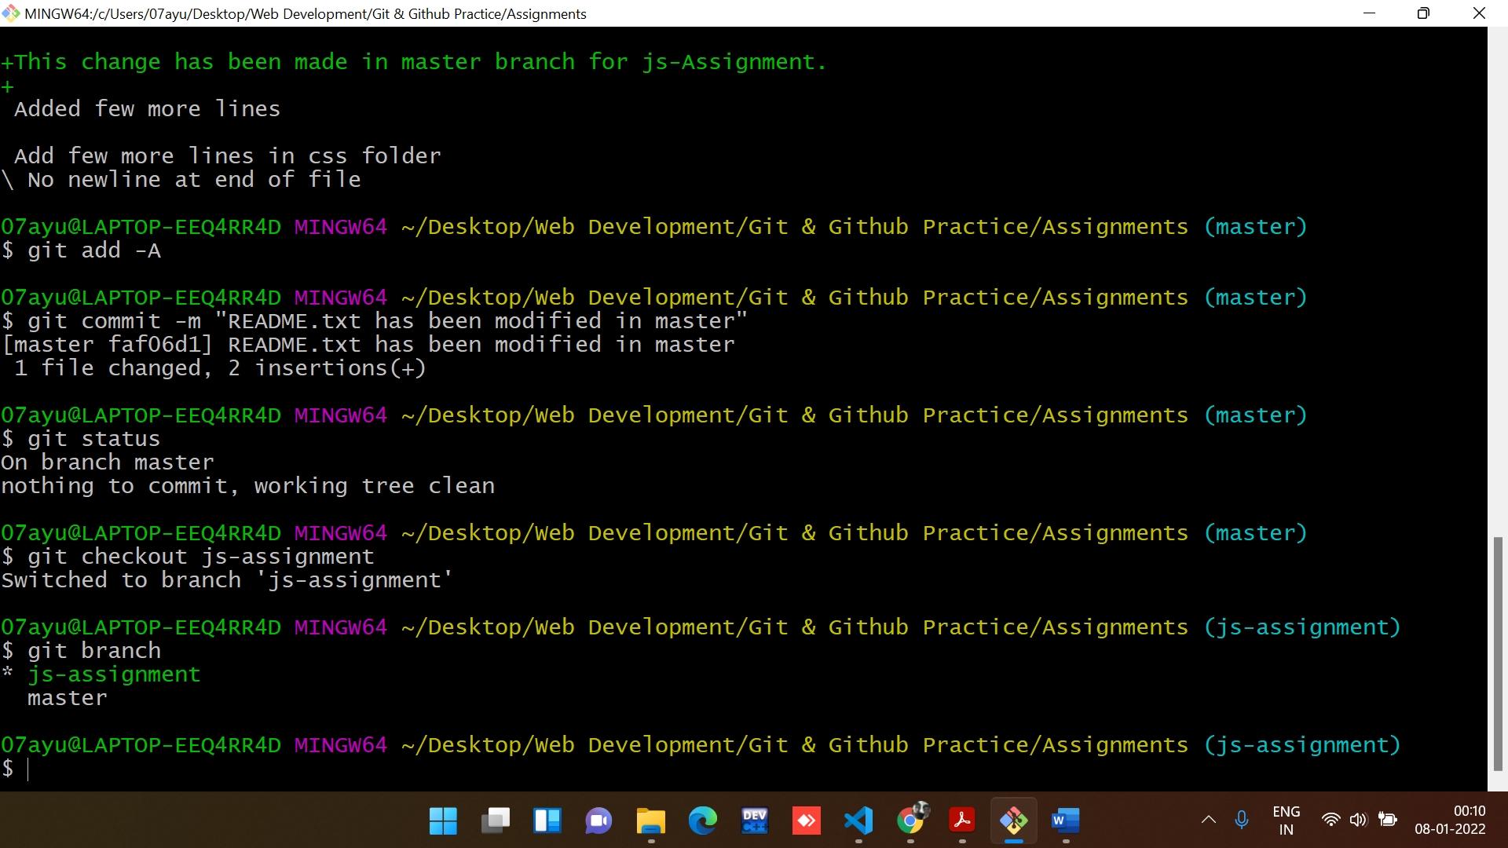

1. Make minor changes into few files belonging to ‘js-assignments’ branch.

Changes has been made in app.js

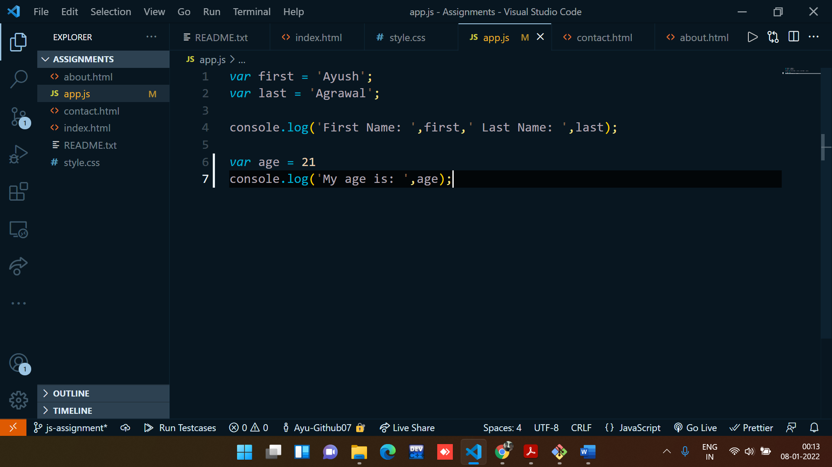

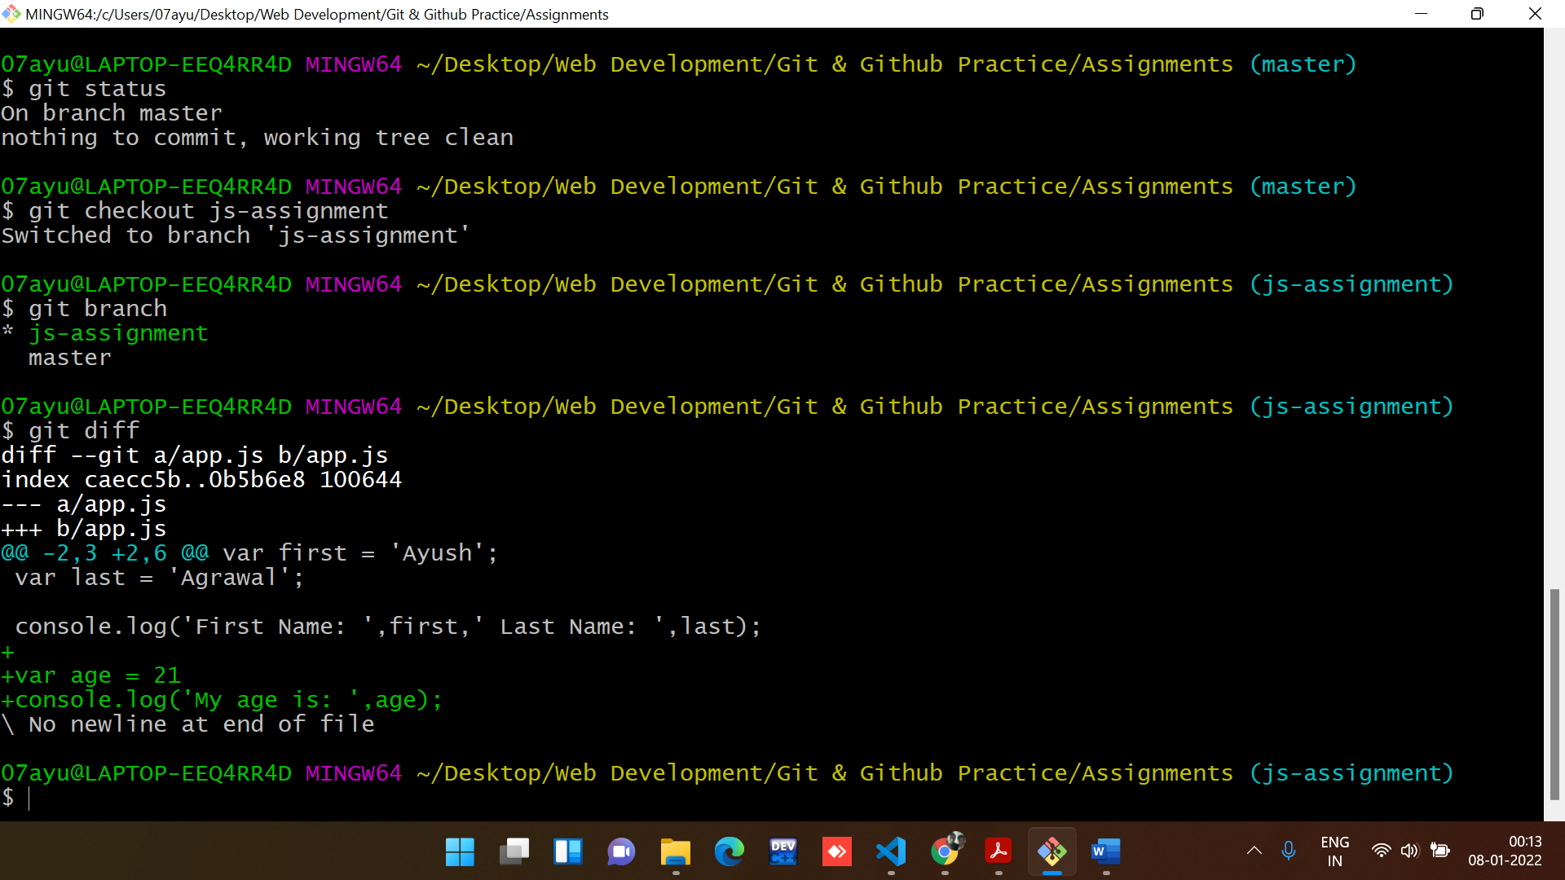

1. Commit those changes.

**Command to commit all the changes:**

git add -A

git commit -m “description”

**Output:**

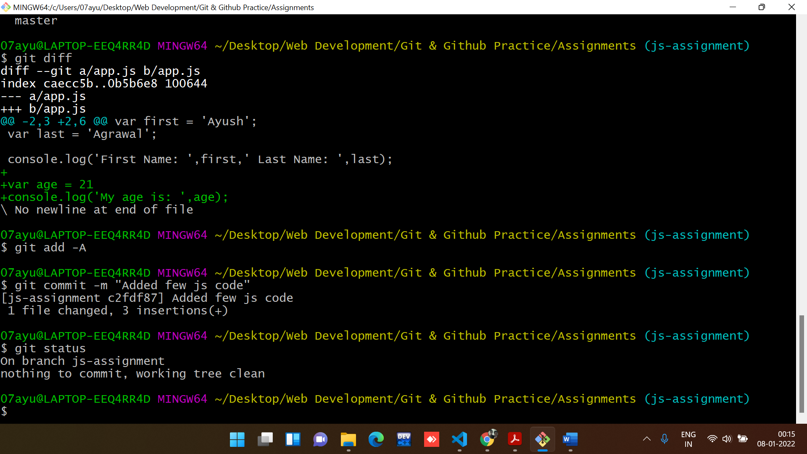

1. Switch to master.

**Command used to switch Branch:**

git checkout master

**Output:**

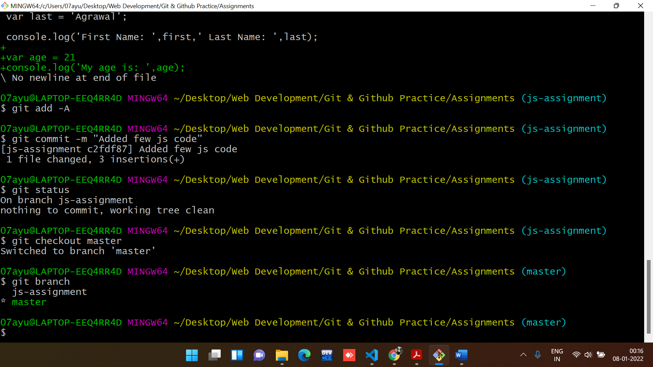

1. Merge ‘js-assignments’ branch into master. Confirm all JavaScript assignments are shown in master.

**Command used to Merge Branches:**

git merge js-assignment

**Output:**

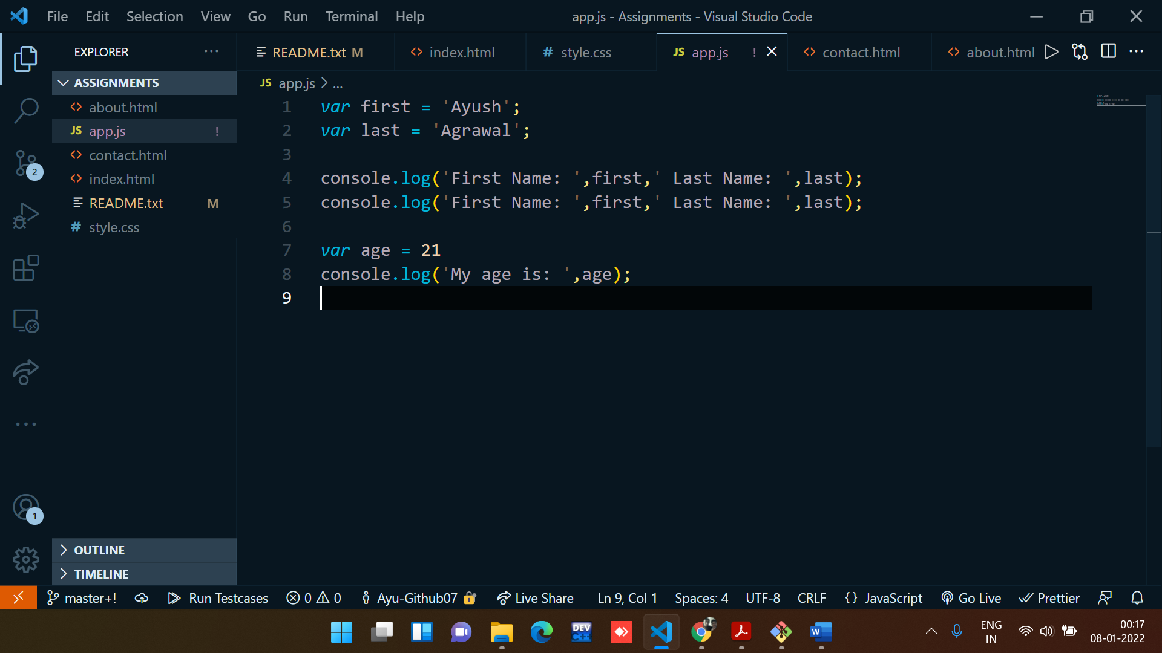

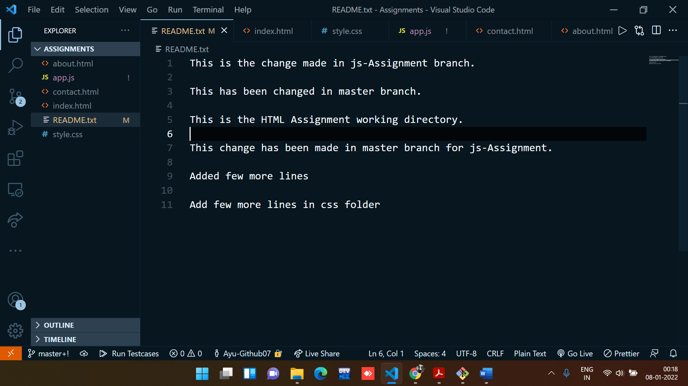

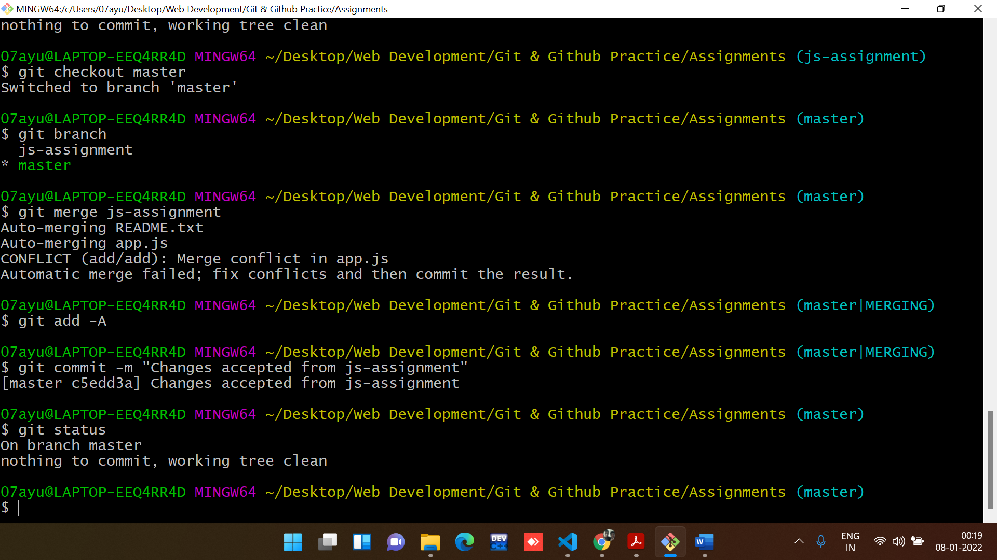

1. Finally delete the ‘js-assignments’ branch.

**Command used to Delete Branches:**

git branch -d js-assignment

**Output:**

